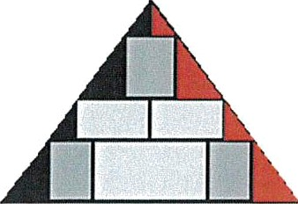
Point Lisas Energy Association of CEOs
c/o Massy Gas Products (Trinidad) Limited
North Sea Drive, Point Lisas Industrial Estate, Savonetta

Guidance for Preparing and Sharing Event Learnings

PURPOSE:

It is widely acknowledged and substantiated that capturing and sharing lessons learned from past failures and events and best practices are pivotal in continual improvement and overall business efficacy. When the stories surrounding the event failures, best practices and STOP WORK events are shared - the valuable insights and experiences allow us to reflect and re-direct how we operate, reduce risks, and improve the overall efficiency and effectiveness of our processes and by extension for our valued business partners / contractors and service providers.

FORMAT and METHODOLOGY:

- A PLEA generated standardized template will be used to populate the details of the event failures / best practices / STOP WORK events. Refer to Appendix I for an illustration of the template.
- The lessons learned will be shared broadly via the PLEA website.
- At a minimum, at least one HSE incident, best practice or STOP WORK Authority event will be shared monthly.
- A schedule will be developed for each operator to share their lesson learned in the prescribed format following which it will be uploaded to the portal, after all the relevant approvals have been obtained, prior to sharing.
- There will be a designated committee member who will be appointed as reviewer and liaison with the Energy Chamber for disseminating amongst the PLEA Operators on the PLEA website.

PROTECTION OF PRIVACY:

- The privacy of individuals, organizations and associations will be highly respected, by anonymity, to safeguard against any public scrutiny and outlash.
- The illustration should exclude any company logos, faces of individuals, titles etc.
Strict adherence to privacy and anonymity must be upheld.

DISCLAIMER:
This document is made available for information only and on the condition that:
- It may not be relied upon by anyone, in the conduct of their own operations, on behalf of a company, or otherwise;
- Neither the company [PLEA] issuing this document nor any other person or company concerned with furnishing information or data used herein (A) is liable for its accuracy or completeness, or for any advice given in or any omission from this document, or for any consequences whatsoever resulting directly or indirectly from any use made of this document by any person, even if there was a failure to exercise reasonable care on the part of the issuing company or any other person or company as aforesaid; or (B) make any claim, representation or warranty, express or implied, that acting in accordance with this document will produce any particular results with regard to the subject matter contained herein or satisfy the requirements of any applicable federal, state or local laws and regulations; and
- Nothing in this document constitutes technical advice, if such advice is required it should be sought from an independent, qualified professional adviser.

APPENDIX I: Event Learning Template

